Lab 1: Understanding ORM with a Retail Inventory System

Objective
To understand Object Relational Mapping (ORM) and create a basic .NET console application with Entity Framework Core packages.

Software Requirements
- Visual Studio Code
- .NET 8 SDK
- C# Dev Kit Extension
- Windows 11

Theory
Object Relational Mapping (ORM) maps C# classes to relational database tables. Entity Framework Core (EF Core) is Microsoft's modern ORM for .NET that allows developers to perform CRUD operations using C# objects instead of writing SQL manually.
Advantages:
- Reduces SQL code
- Improves productivity
- Easier maintenance
- Supports LINQ queries
- Cross-platform with .NET 8

Commands Used
dotnet new console -n RetailInventory
cd RetailInventory
dotnet add package Microsoft.EntityFrameworkCore.SqlServer
dotnet add package Microsoft.EntityFrameworkCore.Design
dotnet run

Program.cs
Console.WriteLine("Retail Inventory System");
Console.WriteLine("Lab 1 - Entity Framework Core");
Console.WriteLine("Project Created Successfully");

Output

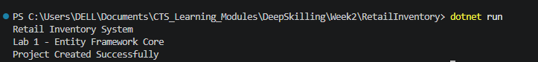

Result
The .NET Console Application was created successfully and the Entity Framework Core packages were installed successfully. The project is ready for the next lab.

